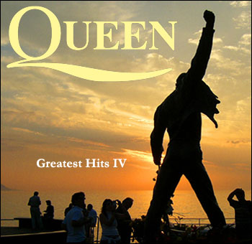
II Unit/ 6th Grade English
P. Bencich/ G. García

Name: ______________________________________Class: 6º________
Date: ____________________________
I. Underline the present perfect verbs. There are 5 verbs.
I've paid my dues -
Time after time -
I've done my sentence
But committed no crime -
And bad mistakes
I've made a few
I've had my share of sand kicked in my face -
But I've come through
II. Read and then Listen to the chorus and fill in the blanks.
We are the 1. _________________ - my friends
And we'll keep on 2. __________________ - till the end -
We are the champions -
We are the champions
No time for 3. ____________________
'Cause we are the champions - of the world -

III. Read and then Listen to the song and fill in the blanks with the correct
form of the present perfect.
I 1. ___________________ (take) my bows
And my curtain calls -
You brought me fame and fortune and everything that goes with it -
I thank you all -
But it 2. _____________ (be) no bed of roses
No pleasure cruise -
I consider it a challenge before the whole human race -
And I ain't gonna lose -
We are the champions - my friends
And we'll keep on fighting - till the end -
We are the champions -
We are the champions
No time for losers
'Cause we are the champions - of the world -
Invent a NEW title for the song!

IV. Closing Activity: Based on the song, write the past simple and the past participle of each of the following verbs:

Infinitive | Past Simple | Present Perfect | Infinitive | Past Simple | Present Perfect
pay | paid | has/have paid | take | took | has/ have taken
do |  |  | be
make |  |  | see
have |  |  | go
come |  |  | finish

Practice: Write sentences with the following verbs using present perfect.

Example: I have lived in Chile since 2011. (live)

Positive:
- You __________________________________________________________. (eat)

- Isidora _______________________________________________________. (see)

Negative:
- We __________________________________________________________. (go)

- My dog ______________________________________________________. (make)

Questions:
- __________ you _____________________________________________? (pay)

- __________ they _____________________________________________? (finish)

