|  |
| --- |
| Saint George´s College  English II Unit  OBJECTIVES  1. To read and comprehend a variety of authentic and adapted texts.  2. To write guided texts that express ideas clearly, in an organized manner, with good word choice, and appropriate conventions.  3. To listen and comprehend the meaning of adapted and authentic oral texts.  5. To express ourselves orally conveying meaning in conversations and oral reports.  6. To explore connections between content material and our Catholic identity.  7. To foster interest and engagement with the English language through technology, using different TICs responsibly and effectively to obtain information and to create texts, citing other’s work and respecting intellectual property.  8. To reinforce listening skills taken from KET test based exercises.  **Teachers:**  **Carolina Ortiz**  [cortizc@saintgeorge.cl](mailto:cortizc@saintgeorge.cl)  **Gabriela García**  [ggarcia@saintgeorge.cl](mailto:ggarcia@saintgeorge.cl) |

**6th Grade**

**Yearly Program** **2019**

**Looking into**

**Our Past, Present,**

**and Future**

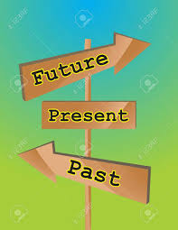

https://www.123rf.com/photo_9432435_wood-board-arrows-vector.html

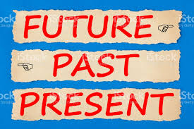

https://www.google.cl/search?q=past+present+past&safe

*Dear students,*

*Welcome to sixth grade English class! We are Miss Carolina and Miss Gaby, and we are very happy to be your teachers this year. Please take a moment to look at our goals for this school year. We believe that it will be a great experience for you to improve your communication skills in English.*

*Miss Carolina and Miss Gaby*

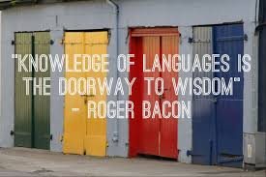

*www.topsimages.com*

***What will you learn?***

|  |  |  |
| --- | --- | --- |
| ***Theme*** | ***Learning Objectives*** | ***Assessments*** |
| **Exploring our Past and Present**  Imagen relacionada  [www.usnews.com](http://www.usnews.com) | * Write organized paragraphs with clear ideas while considering good word choice and conventions such as proper spelling, capitalization, punctuation. (6+1 traits) * Use the dictionary and web resources to define new vocabulary. * Reading Eggs: read and comprehend short texts. * Talk about regular activities and school subjects using present simple in an affirmative, negative and interrogative manner. * Talk and write about past experiences using appropriate vocabulary and the past tense in an affirmative, negative and interrogative manner. * Write and answer Wh- questions clearly. * Write and answer Yes or No questions clearly. * Express organized and clear ideas while considering sentence fluency, good word choice and conventions such as proper grammar and standard pronunciation. * Identify explicit and implicit information from oral conversations and descriptions. * Use of the class web page in order to enhance vocabulary and structures. * Show empathy towards others. * Reflect on the passion and resurrection of Christ. | **Writing Assessment:**  **“*My favourite things”***  **Test 1:**  *Reading*  *Comprehension,*  *Written Expression* |
| **Sharing our experiences**    Resultado de imagen para saint georges college santiago chile<https://www.flickr.com/photos/>  C:\Users\mpullano\Desktop\imgres.png  Resultado de imagen para saint georges college santiago chile  <https://www.flickr.com/photos/> | * Identify main idea and supporting details in an informative text or short story. * Identify character traits. * Describe the characters, setting, and plot of a short story. * Sequence the events of a story. * Make inferences about a text. * Reading Eggs: read and comprehend short texts. * Participate in discussions about a short story. * Participate in Reading Circles developing autonomy. * Use the dictionary and web resources to define new vocabulary. * Talk and write about future arrangements using appropriate vocabulary. * Write organized paragraphs with clear ideas while considering good word choice and conventions such as proper spelling, capitalization, punctuation. (6+1 traits) * Compare people, places, and things using comparative and superlative adjectives. * Express organized and clear ideas while considering sentence fluency, good word choice and conventions such as proper grammar and standard pronunciation. * Use present, past, and future verb tenses in appropriate contexts. * Use present, past, and future interviewing an alumni of St. George´s College. * Listen to and comprehend oral texts. * Present information orally. * Find information in the internet about the Holy Cross Congregation and Saint George`s College. * Recognize the significance of the generosity of St. George´s College within Chilean society as a Catholic school. | **Extensive Reading Project**  *Reading Comprehension*  *Assessment*  **Project**  ***“Sharing our experiences”***  *Oral and written expression* |
| **Communities’ Origins**  Resultado de imagen para our communities  [**https://www.pinterest.cl**](https://www.pinterest.cl)  Resultado de imagen para communities siox  **usatourist.com** | * Reading Eggs: read and comprehend short texts. * Express intentions and predictions for upcoming activities. * Use must and mustn’t to express things that are obligated or prohibited. * Participate in Reading Comprehension Projects (Communities’ Origins) developing autonomy. * Identify main idea and supporting details in an informative text * Summarize a text. * Sequence the events of a text. * Identify causes and effects of events in a text. * Compare and contrast information provided in a text. * Write organized paragraphs with clear ideas while considering good word choice and conventions such as proper spelling, capitalization, punctuation. (6+1 traits) * Use the dictionary and web resources to define new vocabulary. * Use present, past, and future verb tenses in appropriate contexts. * Express organized and clear ideas while considering sentence fluency, good word choice and conventions such as proper grammar and standard pronunciation. * Listen to and comprehend oral texts. * Use web resources to research about communities and real heroes who have changed the world. * Reflect on the importance of having role models to follow. * Express clear ideas about role models. | **Extensive Reading Project**  ***“Communities´***  ***Origins”***  *Reading and written expression project* |
| **The Things People Do!**  Resultado de imagen para go green  bayouvermillion.com  Resultado de imagen para reduce reuse  carecycler.com  Resultado de imagen para reduce reuse recycle examples  www3.canisius.edu | * Reading Eggs: read and comprehend short texts. * Describe people’s personalities. * Use should and shouldn’t to express advice. * Use “What’s it like?” to describe places and people. * Talk about past life experiences and things you have or have never done using the present perfect. * Share experiences about our thoughts and reflections on environmental awareness. * Participate in discussions about environmental issues in Chile. * Compare the environmental issues in Chile with those in other areas of the world. * Write about environmental measures in Chile. * Summarize a text. * Express organized and clear ideas while considering sentence fluency, good word choice and conventions such as proper grammar and standard pronunciation. * Identify facts and opinions in a given text. * Write organized paragraphs with clear ideas while considering good word choice and conventions such as proper spelling, capitalization, punctuation. (6+1 traits) * Use present, past, and future verb tenses in appropriate contexts. * Listen to and comprehend oral texts. * Use the dictionary and web resources to define new vocabulary. * Investigate in the web information related to conservation and environment. * Reflect on the Catholic Social Teaching of Solidarity and Pope Francis´s encyclical *Laudato Si* in relation to our responsibility to care for the environment. | **Test 2**  *Reading*  *Comprehension,*  *Written Expression and Listening*  **Level Assessment**  **Project**  ***“Making a difference in Chile’s future”***  *Written and oral expression project* |

***IMPORTANT MESSAGE FOR PARENTS***

**Please encourage your children to explore and to play on the English class website and the Reading Eggs website at home:**

The English Class website provides you with information and resources for all of the activities, projects, and evaluations we do in class. It also has links to the Reading Eggs website. Check it out! Here is our 6th Grade website:

[*http://stgeorge6thenglish.weebly.com*](http://stgeorge6thenglish.weebly.com)

**Resources**

******http://www.clker.com/clipart-223310.html

***You will need these resources for our class*:**

* *Hobbs Martyn, "Ricky's big Idea", 2011, Helbling Languages ISBN 978-3-85272-335-8*
* *Hobbs Martyn, "Holly, the Eco Warrior", 2007, Helbling Languages ISBN 978-3-902504-41-8*
* Cambridge Pocket Dictionary Spanish – English
* Plastic case
* Copybook
* Pen/Pencil
* Construction paper
* Folder

***You can find more English language resources and games at:***

* <http://stgeorge6thenglish.weebly.com>
* www.readingeggs.com
* www.dictionary.cambridge.org
* www.thesaurus.com
* [www.vocabulary.co.il](http://www.vocabulary.co.il)
* [www.wordreference.com](http://www.wordreference.com)
* [www.britishcouncil.org/kids.htm](http://www.britishcouncil.org/kids.htm)
* [www.kids.nationalgeographic.com](http://www.kids.nationalgeographic.com)
* [www.bbc.co.uk/skillswise](http://www.bbc.co.uk/skillswise/)
* [www.bbc.co.uk/food](http://www.bbc.co.uk/food/)
* [www.paralympics.org.uk](http://www.paralympics.org.uk/)
* [www.bbc.co.uk/schools/](http://www.bbc.co.uk/schools/famouspeople/standard/nightingale/index.shtml)
* [www.biographyonline.com](http://www.biographyonline.com)

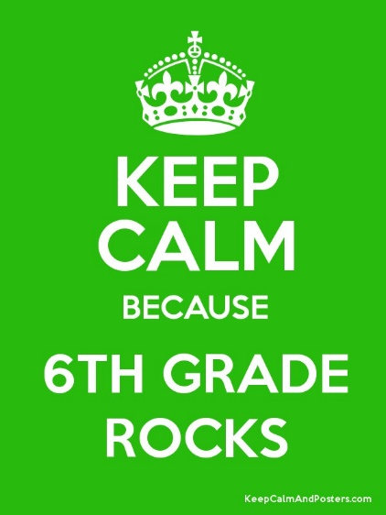

Keepcalmandposters.com